**Graphical User Interface Characterization**

**Menus:**

* SLO- Elevation and clarity of use.  
  -SLI- Menus appear in front of all other permanent UI elements  
  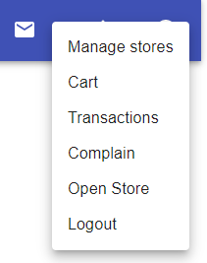
* -SLO- Visibility  
  -SLI- the menu is placed at a maximum height of 14px below the height of the app’s UI.
* SLO-Organization *.*SLI- Menus are placed next to the element that generates them.

**Colors:**

* SLO-Creating a soothing reliable environment.  
  SLI- Using the color blue Makes people feel safe. Blue is a very common color for websites and apps in the travel industry. It represents reliability.  
  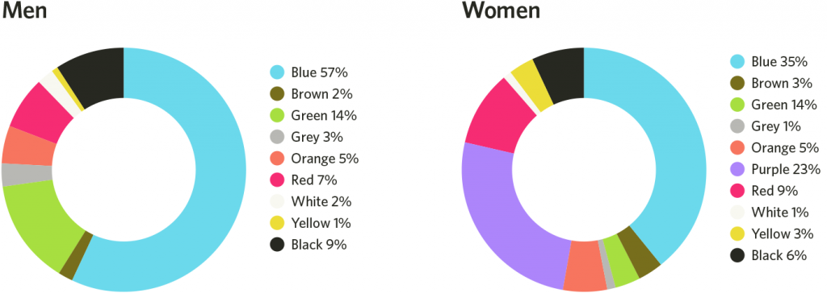
* SLO- accessibility- background-to-text contrast ratio should be at least 4.5:1  
  SLI- Our background-to-text contrast ratio is 7.12 , an “AAA” rating .  
  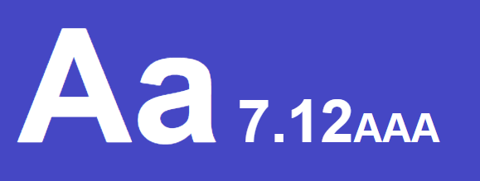  
  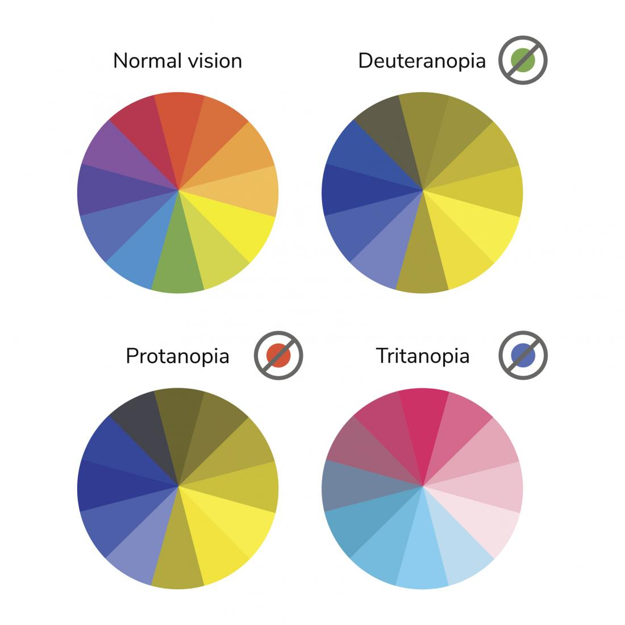

**Headers:**

* SLO – Consistency  
  SLI- The font “raleway” is being used and the headers are consistently placed at the center of the page.
* SLO-The size of the header is greater than the size of other elements in the website.   
  SLI- The header size is 18px, which is greater than the other elements which are at size of 14px.

**Buttons**:

* SLO- Clarity.

SLI- Each button make one action happen and has a label on it.

* SLO- Readable text without reading aids.  
  SLI - buttons are at 16px size .
* SLO – Consistency  
  SLI- The font “raleway” is being used

**Page Layout:**

* SLO - The page is not over crowded .  
  SLI – Maximum 20 visual elements per page.
* SLO – Convenience  
  SLI - No need for left and right scrolling
* SLO – clarity for each graphic element.  
  SLI-No overlapping items, and spacing of 10px and above between every element.

**Errors**:

* SLO – accessibility.  
  SLI - Not relying on color to relay crucial system information and Incorporate error messages.

**Forms and Text Boxes:**

* SLO – clarity of use.  
  SLI - Each form has a guiding label which helps understand what should the user fill in that form.  
  
* SLO – visible and organized page  
  SLI - One column of forms.  
  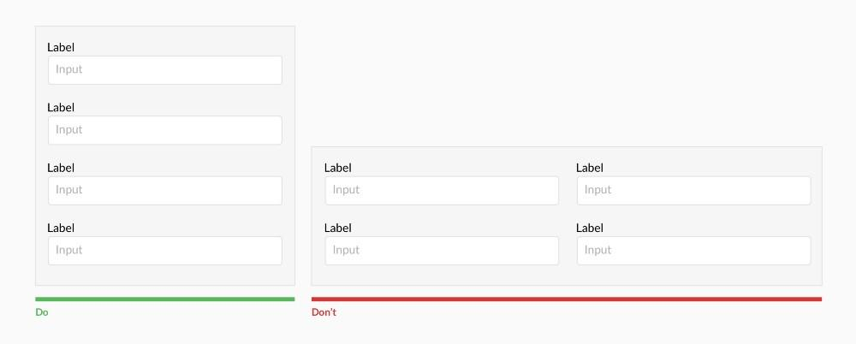
* SLO – Security  
  SLI - if a form contains a password, it will not be displayed to the user upon the screen.

